Docker Networking:

First lets see our master node IP address eth0 , docker0

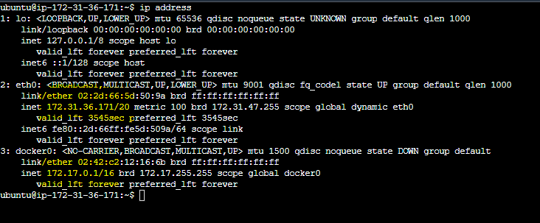

So whatever docker container we will create will be under 172.17.0.X range

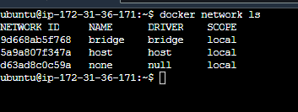

As we said in blog we will have 3 networks created by default when we install docker.

Now lets begin with docker networking,

**Default network,**

docker run -dt --name cont01 donch/net-tools

docker run -dt --name cont02 donch/net-tools

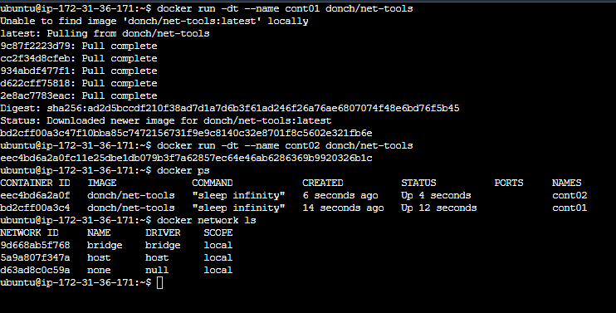

Lets inspect our container and find their IP address,

docker inspect cont01 | grep -i IPAddress

docker inspect cont02 | grep -i IPAddress

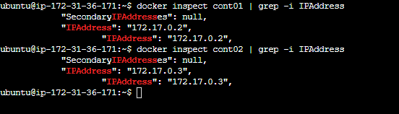

Since they are in same network they can communicate with eachother. Lets try pinging them by entering into one container in interactive mode.

I have shown you both ways you can enter into container using bash (if app is big) else sh (for small app) also they both are able to ping eachother ,hence communication is possible in a default network!!

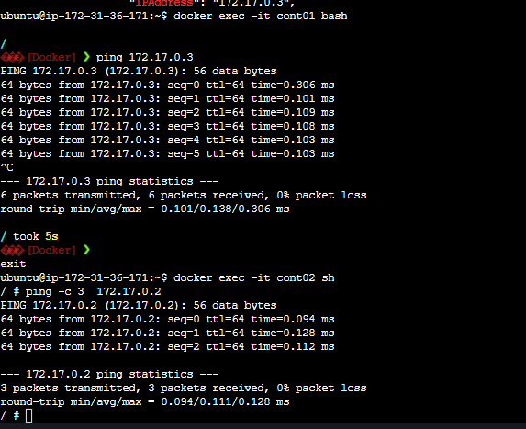

**Let’s move to custom-network,**

Lets create one custom network :

docker network create net-01

docker network ls

# Check the Network IP Range of net-01

docker inspect net-01 (172.18.0.1)

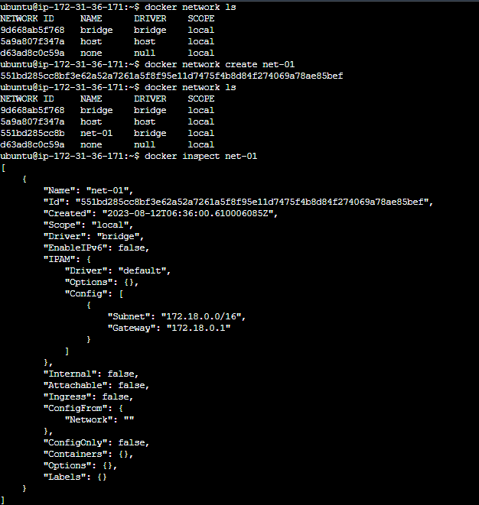

Lets create container in our net-01 network,

docker run -dt --network net-01 --name usr-cont donch/net-tools

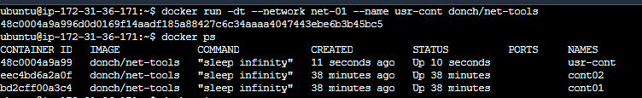

Lets inspect network net-01 to see what is IP address of our container,

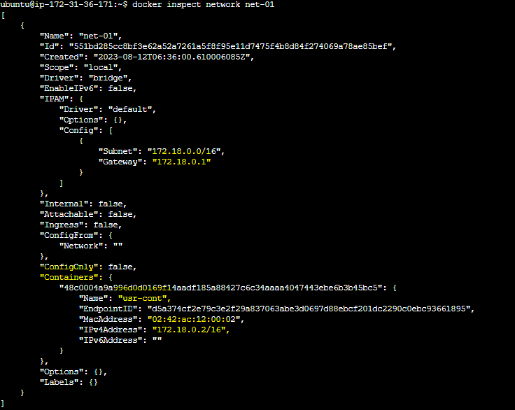

Lets get into container usr-cnt and try to ping containers in our default bridge… (172.17.0.2 or 172.17.0.3)

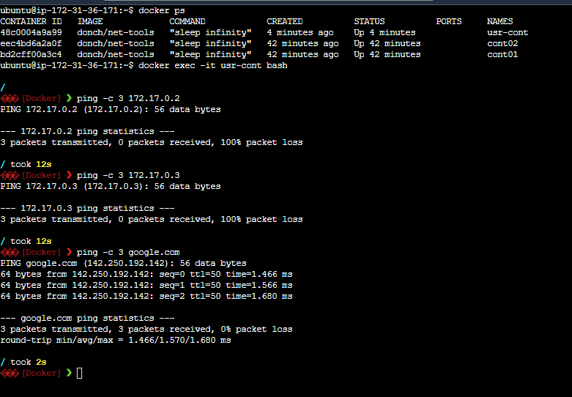

Containers can communicate across network if we connect them or bind them….

Docker network connect bridge usr-cont (this will allow usr-cont container to communicate with containers present in default bridge)

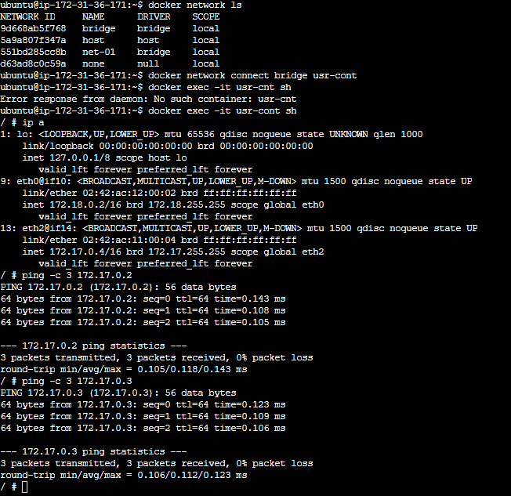

**Note communication is established one way.. it means that usr-cont on net-01 is able to communicate with default bridge containers , default bridge containers cannot communicate with usr-cont under net-01 network.**

Make it happen using docker network connect net-01 cont01 also docker network connect net-01 cont02

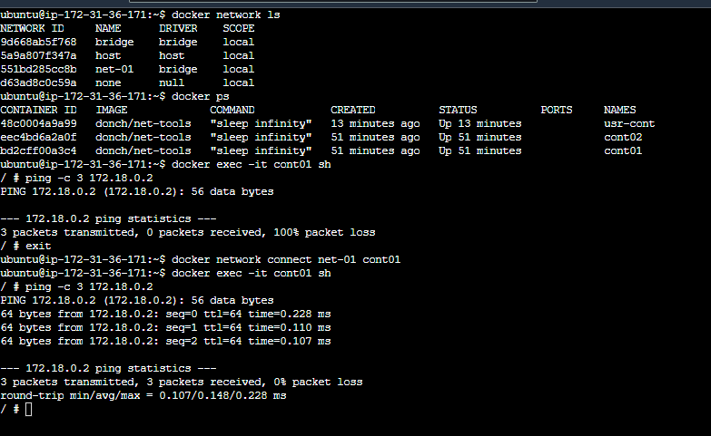

Hope this helps!!!!

Remember to remove unused docker images & containers using prune command….